SET-1

Regulations:
A18

H.T No

Sreenidhi Institute of Science and Technology
(An Autonomous Institution)
Code No: 7C303 Date: 30-Dec-2019 (FN)

B.Tech II-Year I-Semester External Examination, Dec-2019/Jan-2020 (Regular)
SIGNALS AND SYSTEMS (ECE)

Time: 3 Hours Max.Marks:70

Note: a) No additional answer sheets will be provided.
b) All sub-parts of a question must be answered at one place only, otherwise it will not be valued.
c) Missing data can be assumed suitably.

Part - A Max.Marks:20

Answer all QUESTIONS.

1. | List the types of signals. | [2M]
2. | Write the Fourier series expressions for even, odd and half-wave symmetries. | [2M]
3. | What is the condition for system h[n] = β^{n}u[n] to be stable? | [2M]
4. | Distinguish between convolution and correlation. | [2M]
5. | State sampling theorem. | [2M]
6. | Draw the ROC of Z-Transform of a left side sequence and right side sequences in separate diagrams. | [2M]
7. | Find the Hilbert transform of a function f(t) = sinω₀t + cosω₀t. | [2M]
8. | Define filter. Draw the spectrum of ideal LPF. | [2M]
9. | What is aliasing? How to overcome it? | [2M]
10. | Find the convolution between δ(t-1) and δ(t+1)-δ(t). | [2M]

Part – B Max.Marks:50
ANSWER ANY FIVE QUESTIONS. EACH QUESTION CARRIES 10 MARKS.

11. | a) | Express the following signal f(t) in terms of sin(t) using approximation and evaluate mean square error.  f(t) = 1.5 for 0 ≤ t < π  = -1.5 for π ≤ t < 2 π. | [6M]
 | b) | Find the energy, power, even and odd components of the signal u(t). | [4M]
12. | a) | Obtain the relationship between trigonometric and exponential Fourier series coefficients. | [4M]
 | b) | Determine the Fourier Transform of the following signal.  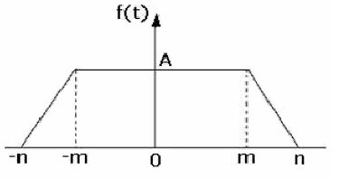  t | [6M]
13. | a) | Check the following systems for linearity and time invariance.  i) y(t) = t²u(t) ii) y[n] = nx[n] | [6M]
 | b) | Write the classification of systems. | [4M]
14. | a) | A system has an impulse response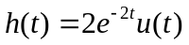. Find the output signal y(t) if the input is x(t) = u(t) – u(t-1) using convolution integral. | [6M]
 | b) | Determine the Laplace Transform of the following standard signals.  i) unit impulse and ii) unit step. | [4M]
15. | a) | Prove sampling theorem for band limited signals. | [6M]
 | b) | What is the need of sampling? List types of sampling techniques. | [4M]
16. | a) | Find the inverse Z-transform of the system  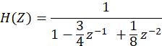  for  i) 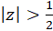 ii) 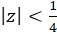 and iii) 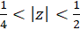 | [6M]
 | b) | State and prove the differentiation in Z-domain and hence compute Z-transform of the signal x[n]= nu[n] | [4M]
17. | a) | Evaluate the integral . | [2M]
 | b) | State and prove the Parseval’s relation for continuous time signals. | [4M]
 | c) | Write the conditions for the existence of Fourier series. | [4M]
18. | a) | Derive the relation between autocorrelation and power spectral density of a signal. | [5M]
 | b) | What is aperture effect? How to overcome it? | [2M]
 | c) | Find the system function of the following linear time invariant discrete system.  y[n] - 2y[n-1] = x[n-1] + 2x[n-2]. | [3M]

-- 00 -- 00 –

